Gravitational Time Dilation as an Alternative Explanation for the Galaxy Rotation Problem
Author: Charles W Rabico Jr
Submitted for scientific commentary and theoretical consideration

Abstract
The Galaxy Rotation Problem, traditionally attributed to the presence of unseen dark matter, may instead be partially or wholly explained by gravitational time dilation. This brief proposes that relativistic differences in time flow across vast galactic scales create observational distortions that mimic the effects currently assigned to dark matter.

Introduction
Galactic rotation curves deviate from predictions based on visible matter: stars at the outer edges of spiral galaxies orbit significantly faster than Newtonian mechanics would allow, given the observable mass. This discrepancy is typically resolved through dark matter—an undetected mass component hypothesized to exert additional gravitational influence.
But this resolution assumes our time measurements across galactic structures are uniform. They are not.

Core Hypothesis
This paper proposes a relativistic correction:
The observed velocity distribution is a misinterpretation caused by time dilation gradients across the galaxy.
- Center of Galaxy: Dominated by a supermassive black hole, time slows dramatically due to gravitational time dilation (per General Relativity).
- Edge of Galaxy: Sparse matter and minimal gravitational curvature allow time to flow closer to flat-spacetime rates.
From an Earth-based observation frame—outside the gravitational influence of both regions—the center appears to “tick” slower and the edge appears to “tick” faster. But these are not differences in velocity—they're differences in time perception.
Thus, the stars at the edges only appear to move faster than they should. Their clocks run faster compared to the core due to weaker gravitational influence, and we misinterpret this relativistic effect as excess velocity requiring dark matter to explain.

Scale Consideration
Galaxies like the Milky Way span ~100,000 light-years. Over such scales, even minor differences in spacetime curvature can compound significantly. In this view, time dilation is not a footnote—it is a dominant perceptual distortion.

Implications
If this hypothesis holds, we may:
- Overestimate the need for dark matter in explaining galactic rotation.
- Misinterpret relativistic effects as mass anomalies.
- Need to reexamine rotation curves using relativistic corrections that include gravitational time dilation across large-scale structures.

Next Steps
- Quantify time dilation gradients from galactic center to edge using known black hole masses and density distributions.
- Simulate relativistic corrections on observed rotation curves.
- Compare against models requiring dark matter halos.
Key Equations:.

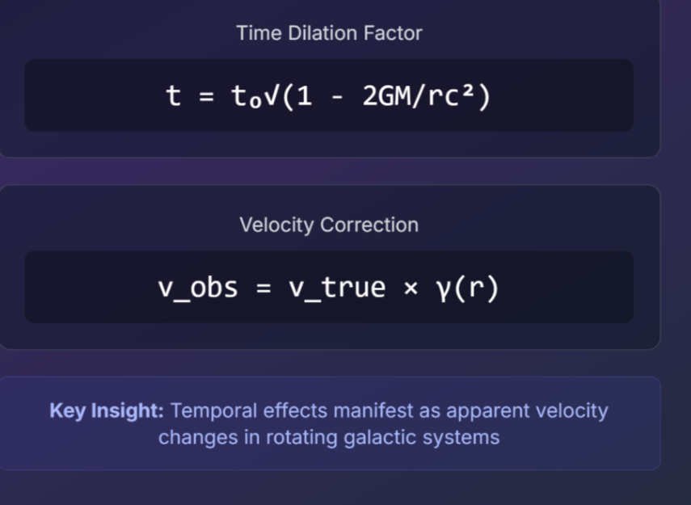

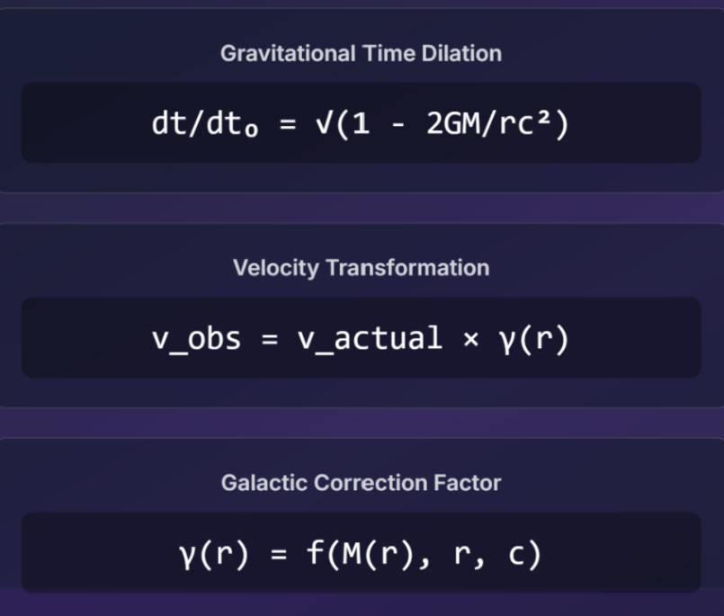

Conclusion
This theory does not deny gravity’s role in galactic dynamics—it reframes the observer’s perception of that gravity. If time flows differently across a galaxy, then the illusion of excess velocity is not a sign of missing matter but of missed perspective.

